UNIcert® III Englisch
Technik

Schriftliche Prüfung

30.Oktober 2020 (2 ½ Stunden)

Name:

 | Erstkorrektor/in | Zweitkorrektor/in
Note
Ggfs. Einigung
Unterschrift

WICHTIGE HINWEISE!!
- Bearbeiten Sie bitte alle Teile der Prüfung und beachten Sie die Anweisungen
- Schreiben Sie Ihren Namen auf jedes Blatt
- Benutzen Sie nur blauen oder schwarzen Stift, keinesfalls Bleistift!

TASK 1: Reading Comprehension (TECH) 30 points (18 Content/12 Language)
Save the document as (LAST NAME_Writ_UNIcertIII_2020) before uploading it.
Type your answers in the boxes below
Read the text then answer the questions in English in your own words.
- What are vibrotacticle displays, in your own words, and what are the drawbacks that the author mentions specifically where vibrational feedback is concerned? 4C.+ 3L
- What makes skin stretch (SS) feedback particularly attractive in its incorporation in skin stretch devices? (List 5 reasons) 5C + 3L
- Compare and contrast the various kinds of research conducted on haptic devices for skin without hair. State what was developed, how it works, and any shortcomings it had. 6C + 3L
- Despite progress having been made in haptic devices for skin with hair, what has caused them to be more limited in their overall effectivity? 3C + 3L

Soft Microtubule Muscle-Driven 3-Axis Skin-Stretch Haptic Devices (Edited)
Written by Thanh Nho Do September 10, 2020
The richest form of communication between human beings is achieved via language that is commonly portrayed using visual or auditory media. However, visual and auditory cues may be disruptive, and therefore they may be inappropriate in many circumstances. Haptics, or the sense of touch, offers humans the ability to explore the surrounding environment and manipulate objects in daily activities. Haptic stimulation provides an alternative way to express information, control balance of the body, provide motion guidance and navigational assistance, or support surgical training.
One method for achieving haptic motion guidance is to apply force feedback to the skin via devices that are mechanically grounded through rigid linkages. However, this method requires a large workspace and bulky and expensive tools. Wearable devices, in contrast, offer compact, flexible, lightweight and low-cost solutions. However, the mechanics of existing wearable devices to interact with human skin still pose many challenges, which severely impacts their usability due to the rigid components. In tele-surgical procedures, surgeons benefit from real-time force feedback to prevent excessive force applied to tissues. In medical training, effective haptic devices can be used to enhance the interaction between medical students and clinicians or provide a useful tool to conduct complex training for surgical procedures within virtual organs without accessing real human tissues.
Among the many types of haptic devices, vibrotactile displays, which apply vibrations to the skin using vibration motors or linear resonant actuators, are the most widespread and investigated, because of the ease of design and actuation. Several methods to provide directional cues via vibrotactile feedback have been described in the literature. To use vibratory feedback, users must learn an association between localized vibration cue and a spatial direction which is inherently difficult to localize because vibrations spread efficiently across the skin surface, leading to desensitization and sensory adaptation, which can impair device functionality over time. In addition, continuously wearing or touching vibrating devices causes the users’ desensitization and discomfort after prolonged use. The effective sensation of vibration feedback can be even decreased when users are in motion.
Recently, skin stretch (SS) feedback has been used to guide human motion and to trace friction or stiffness of the objects or their surface geometry. Several groups have investigated haptic feedback based on an outside force to the skin via a tactor in the form of wearable devices. SS is a known part of the normal physiological apparatus that contributes to our sense of motion and location of arms and legs. The motions and velocities required to give the functionality of skin stretch can be slow, allowing the design of compact, low-power and portable devices. Skin stretch cues that are perceived by a direct source, the sensory system, have been shown as a promising haptic feedback modality in many applications in the last decade due to several superior features. First, skin stretch devices (SSD) manipulate human skin in a way that is similar to natural haptic interactions. Second, SS feedback can provide 3-D directional cues by combining omnidirectional shear force and one normal force as proven in several studies. Third, SSDs would be useful in guiding users without distracting visual or auditory sensation.
Although several wearable haptic devices have been developed, most approaches have focused on wearable tactile feedback devices for the fingertips because the skin there has great density and different types of mechanoreceptors. These haptic devices are able to deliver normal and tangential skin deformation to the finger pad by moving an end effector against the surface of the finger pad while the device itself is grounded to the finger(see Fig. 1). Despite advances, these devices could not provide effective shear forces to communicate with the skin due to the use of rigid components or low energy efficiency from the actuation systems such as onboard rigid DC motors, piezoelectric actuators, dielectric actuators, or tendon-driven mechanisms. For example, Leonardis et al. developed a three-degree of freedom (DoF) skin deformation device that is driven by three rigid servo DC motors through rigid parallel linkages. Although this design shows positive results for grasping objects in virtual environments, it is rigid, bulky and unable to well adapt to the fingertips, which causes discomfort to the users after prolonged use. Solazzi et al. designed a portable haptic device to render the interaction force in virtual environments. This device is mounted directly onto the last part of the finger and actuated by bidirectional cables via pulleys (i.e. a kind of “pulling” system) and DC motors located at the forearm. Although this device could perform a simple task of shape exploration, its wearability is still limited by rigid structures, heavy weight and large size.
Although many studies have concentrated on the mechanoreceptors at the fingertip, there has been less attention to the receptors in skin with hair. Bark et al. presented a wearable rotational SSD. They also investigated the pattern of skin motion and strain imparted by the device. This SSD still has rigid components and is not able to provide both normal and omnidirectional shear forces to the skin. In addition, these aforementioned haptic devices are not able to control the threshold of normal and shear forces to the skin areas in ways that are similar to what is felt during human skin-object interaction. During the interaction, the control of force threshold and motion is extremely important because the way humans sense shear force is highly dependent on their mechanoreceptor density and the distribution of SSDs over the skin surface. Although current SSDs based on soft robotics technology offer high compliance, safety and are lightweight, none of them can effectively induce 3-DoFs skin deformation in the form of finger-worn soft haptic devices. Advances in soft actuation are needed to develop new forms of haptic communication with distributed tactile stimulation in order to promote the progress of science and beneficial impact on human health and life.
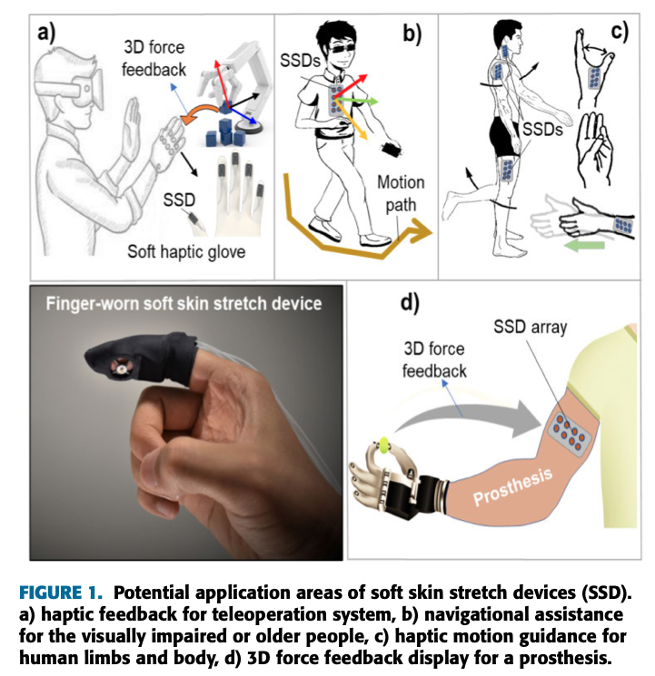

TASK 2: Analytical Writing (GENERAL) (30 points)
Choose ONE of the topics below and write an essay of 300 to 350 words. Remember to give reasons for your position.
(Content: 6 points / Language: 14 points / Structure: 10 points)

Points for structure will be awarded on the basis of:
Overall structure: Introductory paragraph / Paragraphs presenting arguments / Logical conclusion
Transitioning: Appropriate use of logical connectors such as ‘nevertheless’, ‘however’, ‘in addition’.

- Discuss the difficulty of integrating renewable energies into the current energy grid.

- Discuss how manufacturing has changed ever since the inception of Industry 4.0.

- Describe the concept of Smart Cities or Smart Technology and its potential impact on future society.

Type in the box

