UNIcert® III Englisch
Zertifikatsprüfung
Fachgebiet Naturwissenschaften

Schriftliche Prüfung

30. Oktober 2020 (2 ½ Stunden)

Name:

 | Erstkorrektor/in | Zweitkorrektor/in
Note
Ggfs. Einigung
Unterschrift

WICHTIGE HINWEISE!!
- Bearbeiten Sie bitte alle Teile der Prüfung und beachten Sie die Anweisungen
- Schreiben Sie Ihren Namen auf jedes Blatt
- Benutzen Sie nur blauen oder schwarzen Stift, keinesfalls Bleistift!

TASK 1: Reading Comprehension (NATURAL SCIENCE) (30 points)
Read the following text then complete the tasks in English in your own words.
(Content: 20 points / Language: 10 points)

The coronavirus is mutating — does it matter? (adapted from Nature website 09.09.20)
Different SARS-CoV-2 strains have not yet had a major impact on the course of the pandemic, but they might in future.
David Montefiori is a virologist who has spent much of his career studying how chance mutations in HIV help it to evade the immune system. The same thing might happen with SARS-CoV-2, he thought.
In March, Montefiori contacted Bette Korber, an expert in HIV evolution and computational biologist. She had already started scouring thousands of coronavirus genetic sequences for mutations that might have changed the virus’s properties as it made its way around the world.
Compared with HIV, SARS-CoV-2 is changing much more slowly as it spreads. But one mutation stood out to Korber. It was in the gene encoding the spike protein, which helps virus particles to penetrate cells. Korber saw the mutation appearing again and again in samples from people with COVID-19. At the 614th amino-acid position of the spike protein, the amino acid aspartate was regularly being replaced by glycine because of a copying fault that altered a single nucleotide in the virus’s RNA code. Virologists were calling it the D614G mutation.
In April, Korber, Montefiori and others warned that “D614G is increasing in frequency at an alarming rate”. It had rapidly become the dominant SARS-CoV-2 lineage in Europe and had then taken hold in the United States, Canada and Australia. D614G represented a “more transmissible form of SARS-CoV-2”, the paper declared, one that had emerged as a product of natural selection.
The work sparked a frenzy of interest in D614G. Even those who were sceptical that the mutation had changed the virus’s properties agreed that it was intriguing, because of its meteoric rise and ubiquity. For months, that lineage has been found in almost all sequenced samples of SARS-CoV-2 (see ‘Global spread’). “This variant now is the pandemic. As a result, its properties matter,” wrote Nathan Grubaugh, a viral epidemiologist at the Yale School of Public Health.
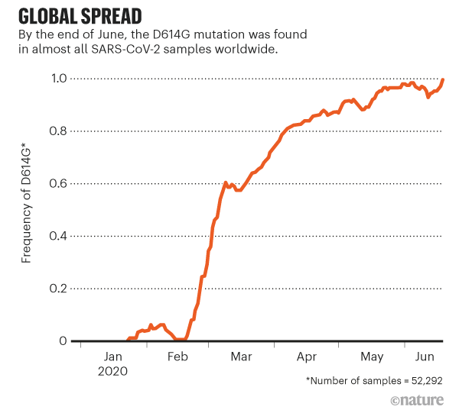
So far, the upshot of this work unclear. Some experiments suggest that viruses carrying the variant infect cells more easily. Other work has revealed possible good news: the variant might mean that vaccines can target SARS-CoV-2 more easily. But many scientists say there remains no solid proof that D614G has a significant effect on the spread of the virus, or that a process of natural selection explains its rise.
Researchers still have more questions than answers about coronavirus mutations, and no one has yet found any change in SARS-CoV-2 that should raise public-health concerns. However, studying mutations in detail could be important for controlling the pandemic. It might also help to pre-empt the most worrying of mutations: those that could help the virus to evade immune systems, vaccines or antibody therapies.

Slow change
Soon after SARS-CoV-2 was detected in China, researchers began analysing viral samples and posting the genetic codes online. Mutations allowed researchers to track the spread by linking closely related viruses, and to estimate when SARS-CoV-2 started infecting humans.
Viruses that encode their genome in RNA, such as SARS-CoV-2, HIV and influenza, tend to pick up mutations quickly as they are copied inside their hosts, because enzymes that copy RNA are prone to making errors. After the severe acute respiratory syndrome (SARS) virus began circulating in humans, for instance, it developed a kind of mutation called a deletion that might have slowed its spread.
However, sequencing data suggest that coronaviruses change more slowly than most other RNA viruses, probably because of a ‘proofreading’ enzyme that corrects potentially fatal copying mistakes. A typical SARS-CoV-2 virus accumulates only two single-letter mutations per month in its genome — a rate of change about half that of influenza and one-quarter that of HIV.
Save the document as (LAST NAME_Writ_UNIcertIII_2020) before uploading it.
Type your answers in the boxes below

Comprehension Tasks:
Complete each of the following tasks using your own words as much as possible. Do not simply copy sections of text from the piece.
- Describe the mutation found by Korber and its effects. (5 marks)

- Describe the meanings of the following (underlined) terms, as used in the text (10 marks):
- Scouring
- Lineage
- Upshot
- Pre-empt
- Evade

- Describe the various research results relating to D614G. (5 marks)

- Summarize the final section (“Slow Change”) in no more than 100 words. (10 marks)

TASK 2: Analytical writing (NATURAL SCIENCE) (30 points)
Choose ONE of the topics below and write an essay of 300 to 350 words. Remember to give reasons for your position.
(Content: 6 points / Language: 14 points / Structure: 10 points)

Points for structure will be awarded on the basis of:
Overall structure: Introductory paragraph / Paragraphs presenting arguments / Logical conclusion
Transitioning: Appropriate use of logical connectors such as ‘nevertheless’, ‘however’, ‘in addition’.

- Artificial intelligence is key to modern scientific research. Discuss.

- Scientists should publish research findings relevant to a pandemic free of charge. Discuss.

- Researchers should concentrate on dealing with the consequences of climate change as it is too late to stop it. Discuss.

- Computer modelling cannot replace animal testing in medicine. Discuss.

- "Dark matter" is just another term for "what we do not yet understand" in modern physics. Discuss.

- It is worth investing billions in space travel. Discuss.

Type in the box below

